Computer communication and networks

**Hamming code & CRC.**

WAQAS ASHIQ.

BCS-F11-201.

SUBMITTED TO:

Sir.Imran Raza.

***Hamming code:***

#include<stdio.h>

#include<math.h>

int main(void){

int a[11];

int r1=0;

int r2=0;

int r3=0;

int r4=0;

int x1=0;

int x2=0;

int x3=0;

int x4=0;

int i=0;

int bitc;

int bd[4];

int sum=0;

int d=0;

double dou=2;

int mp=0;

for(i=0;i<11;i++){

if(i==0||i==1||i==3||i==7){

printf("This place is for redundent bit\n");

a[i]=0;

}

else{

printf("Enter the data bits:");

scanf("%d",&a[i]);

}

}

printf("\nAssigning the values to the redundancy bits:");

for(i=0;i<=10;i++){

if(i==2||i==4||i==6||i==8||i==10){

if(a[i]==1){

r1++;

}

else{

}

if(r1%2==0){

a[0]=0;

}

else{

a[0]=1;

}

}

if(i==2||i==5||i==6||i==9||i==10){

if(a[i]==1){

r2++;

}

else{

}

if(r2%2==0){

a[1]=0;

}

else{

a[1]=1;

}

}

if(i==4||i==5||i==6){

if(a[i]==1){

r3++;

}

else{

}

if(r3%2==0){

a[4]=0;

}

else{

a[4]=1;

}

}

if(i==8||i==9||i==10){

if(a[i]==1){

r4++;

}

else{

}

if(r4%2==0){

a[7]=0;

}

else{

a[7]=1;

}

}

}

printf("\nThis is the final data to be send:\n");

for(int l=10;l>=0;l--){

printf("%d--",a[l]);

}

printf("\nThese are the redundant bits\nr1=%d\nr2=%d\nr3=%d\nr4=%d",a[0],a[1],a[3],a[7]);

input: printf("\nEnter the bit number between 0-11 you want to change: ");

scanf("%d",&bitc);

bitc--;

if(bitc>10 && bitc<0){

printf("\ninvalid bit entered");

goto input;

}

else{

if(a[bitc]==1){

a[bitc]=0;

}

else{

a[bitc]=1;

}

}

printf("\nNow erroneous bit will be detected:");

for(int i=0;i<=10;i++){

if(i==0||i==2||i==4||i==6||i==8||i==10){

if(a[i]==1){

x1++;

}

else{

}

if(x1%2==0){

bd[0]=0;

}

else{

bd[0]=1;

}

}

if(i==1||i==2||i==5||i==6||i==9||i==10){

if(a[i]==1){

x2++;

}

else{

}

if(x2%2==0){

bd[1]=0;

}

else{

bd[1]=1;

}

}

if(i==3||i==4||i==5||i==6){

if(a[i]==1){

x3++;

}

else{

}

if(x3%2==0){

bd[2]=0;

}

else{

bd[2]=1;

}

}

if(i==7||i==8||i==9||i==10){

if(a[i]==1){

x4++;

}

else{

}

if(x4%2==0){

bd[3]=0;

}

else{

bd[3]=1;

}

}

}

printf("\nThis is the final perioty\n");

for(int q=3;q>=0;q--){

printf("%d--",bd[q]);

}

for(int k=0;k<4;k++){

int d=bd[k];

mp=d*pow(dou,k);

sum=sum+mp;

}

getchar();

printf("\nThe error is on bit number: %d ",sum);

getchar();

return 0;

}

**OutPut:**

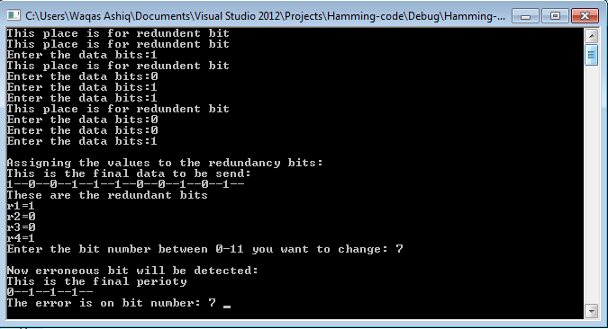

**CRC Code:**

#include<stdlib.h>

#include<conio.h>

#include<stdio.h>

int main()

{

int i,j,n,p,a,s=0;

int dat[20],pol[20],b[20],q[20];

printf("\nEnter no. of data bits:");

scanf("%d",&n);

for(i=0;i< n;i++){

printf("Enter %d data bit:",(i+1));

scanf("%d",&dat[i]);

}

printf("Enter size of polynomial:");

scanf("%d",&p);

do{

printf("Enter %dbit polynomial:",p);

for(j=0;j< p;j++)

scanf("%d",&pol[j]);

}

while(pol[0]!=1);

printf("\nThe polynomial is:");

for(j=0;j< p;j++)

printf("%d",pol[j]);

a=n+(p-1);

printf("\nThe appended Data is:");

for(i=0;i< a;++i){

dat[n+i]=0;

}

for(i=0;i< a;++i){

printf("%d",dat[i]);

}

for(i=0;i< n;++i){

q[i]= dat[i];

}

for(i=0;i< n;++i)

{

if(dat[i]==0)

{

for(j=i;j< p+i;++j)

dat[j] = dat[j]^0;

}

else

{

dat[i] = dat[i]^pol[0];

dat[i+1]=dat[i+1]^pol[1];

dat[i+2]=dat[i+2]^pol[2];

dat[i+3]=dat[i+3]^pol[3];

}

}

printf("\nThe CRC is :");

for(i=n;i < a;++i){

printf("%d",dat[i]);

s=n+a;

}

for(i=n;i< s;i++){

q[i]=dat[i];

}

printf("\nThe Data send to the reciver is:");

for(i=0;i< a;i++){

printf("%d",q[i]);

}

getch();

}

**CRC OutPut:**

